What is Computer :
Computer is an electronic device that is designed to work with Information. The term computer is derived from the Latin term ‘computare’, this means to calculate or programmable machine. Computer can not do anything without a Program. It represents the decimal numbers through a string of binary digits. The Word 'Computer' usually refers to the Center Processor Unit plus Internal memory.
Charles Babbage is called the "Grand Father" of the computer. The First mechanical computer designed by Charles Babbage was called Analytical Engine. It uses read-only memory in the form of punch cards.
Computer is an advanced electronic device that takes raw data as input from the user and processes these data under the control of set of instructions (called program) and gives the result (output) and saves output for the future use. It can process both numerical and non-numerical (arithmetic and logical) calculations.
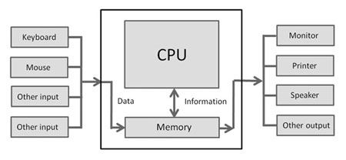
Basic characteristics about computer are:
1. Speed: - As you know computer can work very fast. It takes only few seconds for calculations that we take hours to complete. You will be surprised to know that computer can perform millions (1,000,000) of instructions and even more per second.
Therefore, we determine the speed of computer in terms of microsecond (10-6 part of a second) or nanosecond (10 to the power -9 part of a second). From this you can imagine how fast your computer performs work.
2. Accuracy: - The degree of accuracy of computer is very high and every calculation is performed with the same accuracy. The accuracy level is 7.

determined on the basis of design of computer. The errors in computer are due to human and inaccurate data.
3. Diligence: - A computer is free from tiredness, lack of concentration, fatigue, etc. It can work for hours without creating any error. If millions of calculations are to be performed, a computer will perform every calculation with the same accuracy. Due to this capability it overpowers human being in routine type of work.
4. Versatility: - It means the capacity to perform completely different type of work. You may use your computer to prepare payroll slips. Next moment you may use it for inventory management or to prepare electric bills.
5. Power of Remembering: - Computer has the power of storing any amount of information or data. Any information can be stored and recalled as long as you require it, for any numbers of years. It depends entirely upon you how much data you want to store in a computer and when to lose or retrieve these data.
6. No IQ: - Computer is a dumb machine and it cannot do any work without instruction from the user. It performs the instructions at tremendous speed and with accuracy. It is you to decide what you want to do and in what sequence. So a computer cannot take its own decision as you can.
7. No Feeling: - It does not have feelings or emotion, taste, knowledge and experience. Thus it does not get tired even after long hours of work. It does not distinguish between users.
8. Storage: - The Computer has an in-built memory where it can store a large amount of data. You can also store data in secondary storage devices such as floppies, which can be kept outside your computer and can be carried to other computers.

Limitations of Computer Systems
Limitations are the drawbacks of the computer system in which humans outperform them.
Lack of common-sense
This is one of the major limitations of computer systems. No matter how efficient, fast and reliable computer systems might be but yet do not have any common sense because no full-proof algorithm has been designed to programme logic into them. As computers function based on the stored programme(s), they simply lack common sense.

Zero IQ
Another of the limitations of computer systems is that they have zero Intelligence Quotient (IQ). They are unable to see and think the actions to perform in a particular situation unless that situation is already programmed into them. Computers are programmable to complete each and every task, however small it may be.
Lack of Decision-making
Decision-making is a complicated process involving information, knowledge, intelligence, wisdom, and ability to judge. The computer system does not have the ability to make decisions on their own because they do not possess all the essentials of decision-making.
They can be programmed to take such decisions, which are purely procedure-oriented. If a computer has not been programmed for a particular decision situation, it will not take a decision due to lack of wisdom and evaluation faculties. Human beings, on the other hand, possess this great power of decision-making.
Types of Computers:
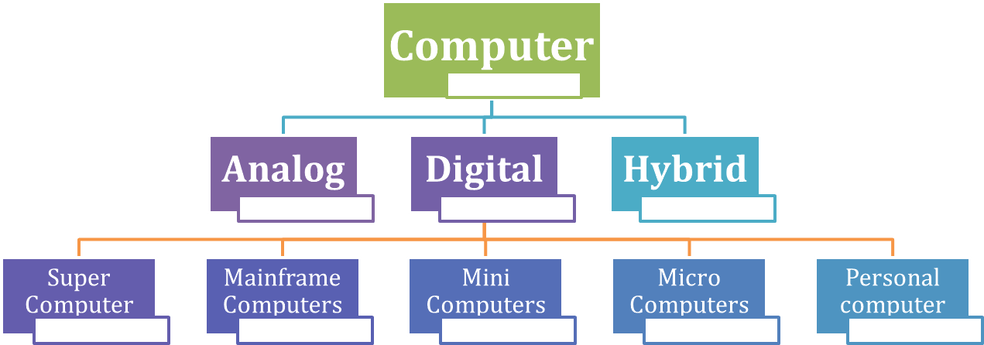
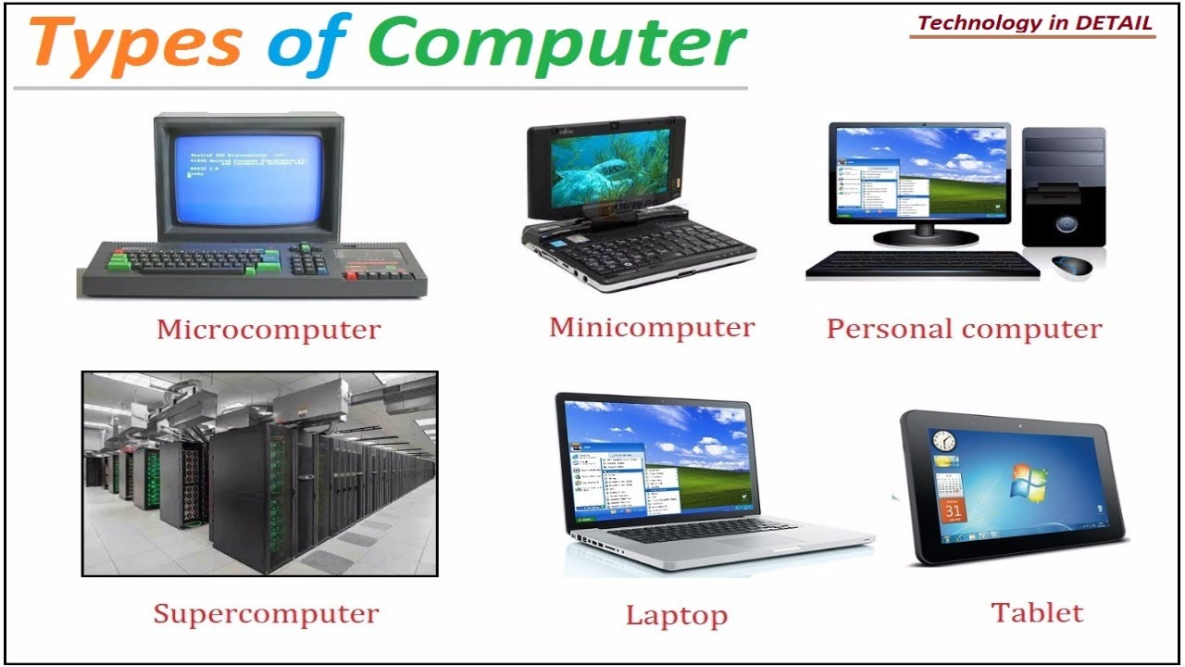

We are surrounded by computer world. It is impossible to live without all these computer gadgets like computers, laptops, mobile phones whether at home, office or while traveling. When a common man thinks of it, it is personal computer i.e. desktop or laptop. However, computer have different shapes and sizes and perform different functions. Following are the four different types of computers.
- Microcomputer
- Minicomputer
- Mainframe Computer
- Supercomputer
Microcomputer
These are also known as personal computers (PCs). They are small in sizes and relatively inexpensive. They are highly flexible and designed for small scale personal use and business application. these are based on microprocessor technology, a silicon chip containing the important circuitry to perform operations. IBM, Dell, Sony, HP and Apple are the manufactures of microcomputers. Nowadays they have come more advance and powerful in technology.

Minicomputer
Compare to mainframe these are midrange computers, small in size and more compact and less expensive. They are designed for computerization of data, scientific research, industrial process, data collection and telephone switches. Minicomputers are multiprocessing system and can support upto 200 user at a time but the power of processing is not as great as the mainframe and supercomputers. Timesharing, batch processing and online processing is available on these midrange computers and are often now referred to as small or midsize servers.
Examples of Minicomputers
IBM System/3
Honeywell 200
TI-990
Mainframe Computer
Mainframe computers can store huge amount of data. They are large in size and memory, power and expensive. These machines are capable to different operating system on the same time and support time sharing and virtual memory. Universities, banking institutions, stock exchanges, insurance companies are some examples of using mainframe servers for maintaining students’ data, ATM transactions, financial transactions, clients and employees’ records.
The main difference between supercomputer and mainframes is that supercomputer has a speed of calculations and mostly used for space scientific and engineering related problems i.e. data crunching while mainframe servers are used for transaction process.
Modern mainframes Computers
IBM zSeries
System z9
System z10 servers
Supercomputer
The term “super computer” is considered the most powerful computers in performance and processing. Supercomputers are capable to solve immense mathematical calculations, scientific problems and hence it is called number crunchers. They are difficult to design and need teamwork research and development.
First Ever Supercomputer
The world first supercomputer CDC 6600 was released by designed by Seymour Cray.
Fastest Supercomputer in the World
In the run of supercomputers China is still No. 1. According to top500 list, since June 2013 Tianhe-2 is the fastest supercomputer in the world developed by China’s National University of Defense Technology. It is capable to perform 33.86 petaflops (quadrillions of calculations per second). It can best use for simulation, analysis and government security applications.
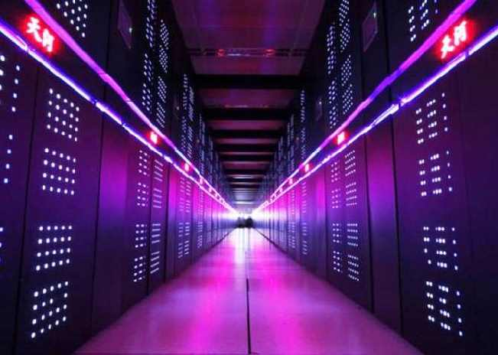
Uses of Supercomputer
Theses monster machines are capable to play their role in the field of weather forecasting, quantum mechanics and physical simulation (spaceship aerodynamics and testing of nuclear weapons. Another important application of supercomputer is oil exploration. A program can simulate areas where oil is likely to be found and can predict costs and methods of findings and retrieving oil.
Examples of Some Supercomputer
IBM Roadrunner
Trinity by Cray Inc.
IBM Sequoia

What is an Analog Computer?
An Analog computer or Analogue computer is a computer which uses continuously changeable entities like mechanical, electrical, hydraulic, etc. quantities in any problem which is being solved.
They were first used at the time of 1950’s – 1960’s. They do not use discrete values, but rather continuous values.
Those computers work on an analogue signal. These signals are the continuous signals for which the time varying feature (variable) of the signal is a representation of some other time varying quantity, i.e., analogous to another time varying signal.
Analogue computers are used in some specific applications, like the flight computer in aircraft, ships, submarines, and some appliances around us like the refrigerator, speedometer of your bike, etc.

What is a Digital Computer?
They are the computers that perform various computational as well as some other general purpose tasks. The information in these computers is represented by variables that take a limited number of discrete values.
Those computers work on a digital signal. These signals are used to represent data as a sequence of discrete values; at any given time it can only take on one of a finite number of values.
Digital computers use the binary number system, which has two digits i.e., 0 and 1. A binary digit is called a bit. Here the information is represented in the groups of bits.
The advantages of a digital computer are that they are accurate, fast, re-programmable and the outputs are least affected by outside disturbances.
Some of the best examples of digital computers are your laptop, calculators, smartphones, etc.
Analog computers
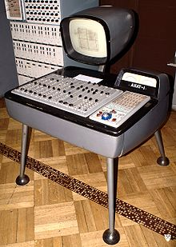
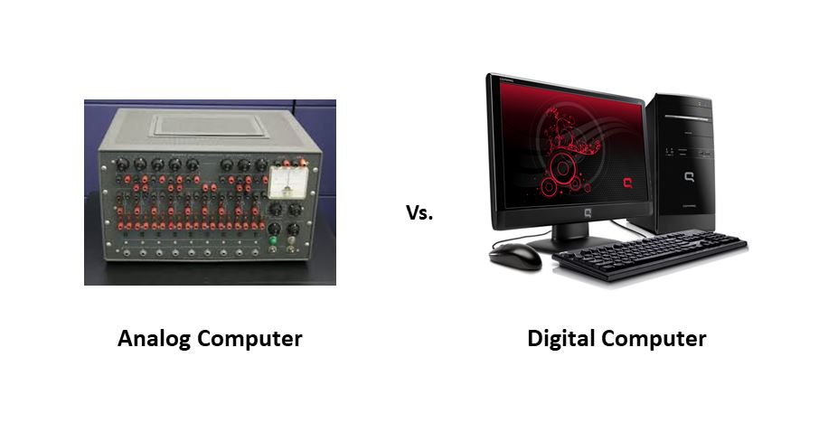

Generations of computers:

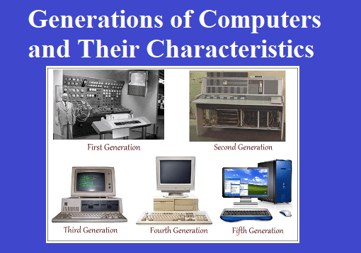

First Generation: Vacuum Tubes (1940-1956)
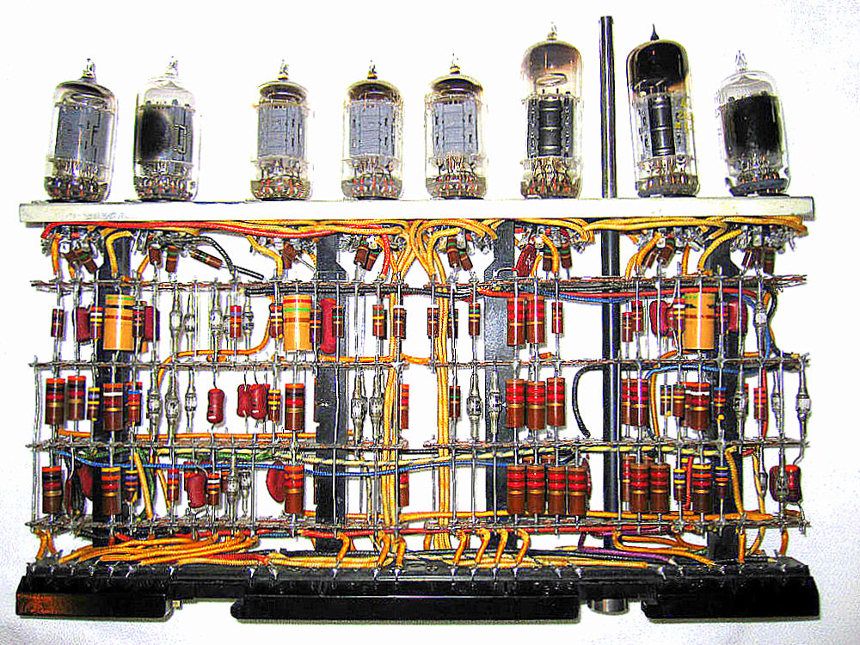

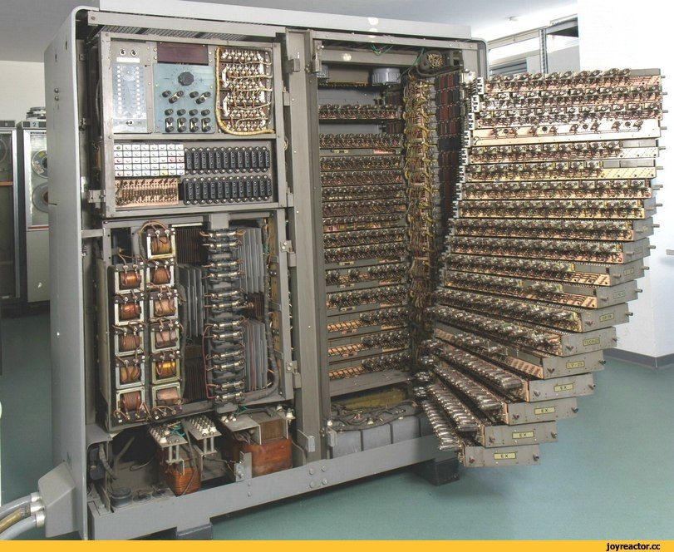
The first computer systems used vacuum tubes for circuitry and magnetic drums for memory, and were often enormous, taking up entire rooms. These computers were very expensive to operate and in addition to using a great deal of electricity, the first computers generated a lot of heat, which was often the cause of malfunctions.
First generation computers relied on machine language, the lowest-level programming language understood by computers, to perform operations, and they could only solve one problem at a time. It would take operators days or even weeks to set-up a new problem. Input was based on punched cards and paper tape, and output was displayed on printouts.
The UNIVAC and ENIAC computers are examples of first-generation computing devices. The UNIVAC was the first commercial computer delivered to a business client, the U.S. Census Bureau in 1951.
Second Generation: Transistors (1956-1963)
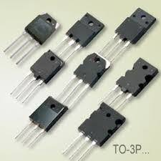
The world would see transistors replace vacuum tubes in the second generation of computers. The transistor was invented at Bell Labs in 1947 but did not see widespread use in computers until the late 1950s.
The transistor was far superior to the vacuum tube, allowing computers to become smaller, faster, cheaper, more energy-efficient and more reliable than their first-generation predecessors. Though the transistor still generated a great deal of heat that subjected the computer to damage, it was a vast improvement over the vacuum tube. Second-generation computers still relied on punched cards for input and printouts for output.

Third Generation: Integrated Circuits (1964-1971)
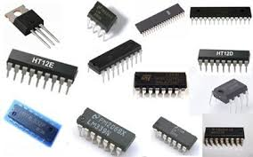
The development of the integrated circuit was the hallmark of the third generation of computers. Transistors were miniaturized and placed on silicon chips, called semiconductors, which drastically increased the speed and efficiency of computers.
Instead of punched cards and printouts, users interacted with third generation computers through keyboards and monitors and interfaced with an operating system, which allowed the device to run many different applications at one time with a central program that monitored the memory. Computers for the first time became accessible to a mass audience because they were smaller and cheaper than their predecessors.
Fourth Generation: Microprocessors (1971-Present)
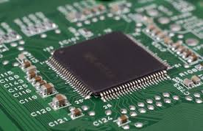
The microprocessor brought the fourth generation of computers, as thousands of integrated circuits were built onto a single silicon chip. What in the first generation filled an entire room could now fit in the palm of the hand. The Intel 4004 chip, developed in 1971, located all the components of the computer—from the central processing unitand memory to input/output controls—on a single chip.
In 1981 IBM introduced its first computer for the home user, and in 1984 Apple introduced the Macintosh. Microprocessors also moved out of the realm of desktop computers and into many areas of life as more and more everyday products began to use microprocessors.
As these small computers became more powerful, they could be linked together to form networks, which eventually led to the development of the Internet. Fourth generation computers also saw the development of GUIs, the mouseand handheld devices.

Fifth Generation: Artificial Intelligence (Present and Beyond)
Fifth generation computing devices, based on artificial intelligence, are still in development, though there are some applications, such as voice recognition, that are being used today. The use of parallel processing and superconductors is helping to make artificial intelligence a reality.
Quantum computation and molecular and nanotechnology will radically change the face of computers in years to come. The goal of fifth-generation computing is to develop devices that respond to natural language input and are capable of learning and self-organization.
SERVERS
Nearly all personal computers are capable of serving as network servers. However, usually software/hardware system dedicated computers have features and configurations just for this task.
For example, dedicated servers may have high-performance RAM, a faster processor and several high-capacity hard drives. In addition, dedicated servers may be connected to redundant power supplies, several networks and other servers.
Such connection features and configurations are necessary as many client machines and client programs may depend on them to function efficiently, correctly and reliably.
In order to operate in the unique network environment where many computers and hardware/software systems are dependent on just one or several server computers, a server often has special characteristics and capabilities, including:
- The ability to update hardware and software without a restart or reboot.
- Advanced backup capability for frequent backup of critical data.
- Advanced networking performance.
- Automatic (invisible to the user) data transfer between devices.
- High security for resources, data and memory protection.
Server computers often have special operating systems not usually found on personal computers. Some operating systems are available in both server and desktop versions and use similar interfaces. However, an increase in the reliability of both server hardware and operating systems has blurred the distinctions between desktop and server operating systems.
Smart System
You can imagine a smart system as basically a system which has some intelligence, some smartness to it. For example, a phone used to function only for making and receiving calls but nowadays smartphones do so much more than just calling - you can access your mail, open various apps like Facebook, Instagram and many more. In fact, there is virtually nothing that you cannot do from a smartphone.
Similarly you can try to understand a smart system in terms of smart homes. A smart home is so much more than an average home. A smart home is basically a home which is automated and works upon the principle of IoT (Internet of Things). A smart home can turn on your AC for you or close the curtains or set the weather to a perfect temperature.
Smart systems are the ones which makes human life more and more Easier & convenient .It has a huge impact as technology gets updated day by day and influences everyone’s life .Smart systems are being adopted by each and every aspect of business . Home Automation System is one of those aspects which have completely adopted Smart Systems .
Artificial Intelligence have boosted the Automation systems making it way smarter than it was before .
Smart Systems means having Convenience in your hands from anywhere in the world . Ever imagined that your Home Appliances functions on its own …this is what a Smart Home System provides you with .

Embedded System
As its name suggests, Embedded means something that is attached to another thing. An embedded system can be thought of as a computer hardware system having software embedded in it.
An embedded system can be an independent system or it can be a part of a large system. An embedded system is a microcontroller or microprocessor based system which is designed to perform a specific task. For example, a fire alarm is an embedded system; it will sense only smoke.
An embedded system has three components −
- It has hardware.
- It has application software.
- It has Real Time Operating system (RTOS) that supervises the application software and provide mechanism to let the processor run a process as per scheduling by following a plan to control the latencies. RTOS defines the way the system works. It sets the rules during the execution of application program. A small scale embedded system may not have RTOS.
Some examples of embedded systems are MP3 players, mobile phones, video game consoles, digital cameras, DVD players, and GPS. Household appliances, such as microwave ovens, washing machines and dishwashers, include embedded systems to provide flexibility and efficiency.
So we can define an embedded system as a Microcontroller based, software driven, reliable, real-time control system.

GIS
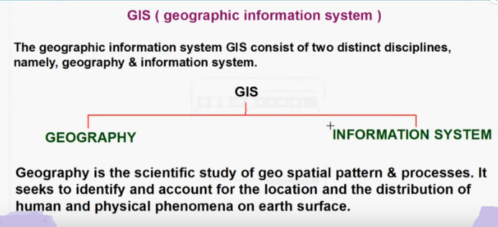

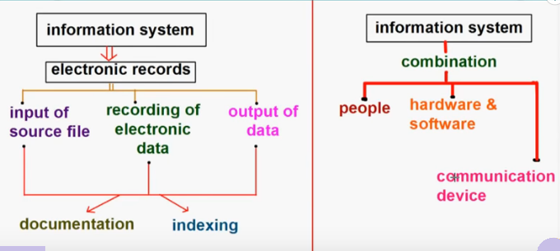

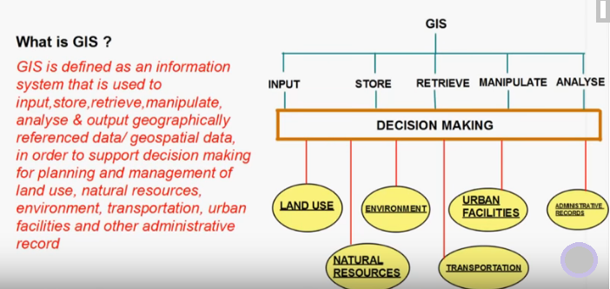
A Geographic Information System (GIS Software) is designed to store, retrieve, manage, display, and analyze all types of geographic and spatial data. GIS software lets you produce maps and other graphic displays of geographic information for analysis and presentation.
GIS software lets you produce maps and other graphic displays of geographic information for analysis and presentation. With these capabilities a GIS is a valuable tool to visualize spatial data or to build decision support systems for use in your organization.
A GIS stores data on geographical features and their characteristics. The features are typically classified as points, lines, or areas, or as raster images. On a map city data could be stored as points, road data could be stored as lines, and boundaries could be stored as areas, while aerial photos or scanned maps could be stored as raster images.
Geographic Information Systems store information using spatial indices that make it possible to identify the features located in any arbitrary region of a map. For example, a GIS can quickly identify and map all of the locations within a specified radius of a point, or all of the streets that run through a territory.

GPS(Global Positioning System)
Stands for "Global Positioning System." GPS is a satellite navigation system used to determine the ground position of an object. GPS technology was first used by the United States military in the 1960s and expanded into civilian use over the next few decades. Today, GPS receivers are included in many commercial products, such as automobiles, smartphones, exercise watches, and GIS devices.
The GPS system includes 24 satellites deployed in space about 12,000 miles (19,300 kilometers) above the earth's surface. They orbit the earth once every 12 hours at an extremely fast pace of roughly 7,000 miles per hour (11,200 kilometers per hour). The satellites are evenly spread out so that four satellites are accessible via direct line-of-sight from anywhere on the globe.

How GPS work?
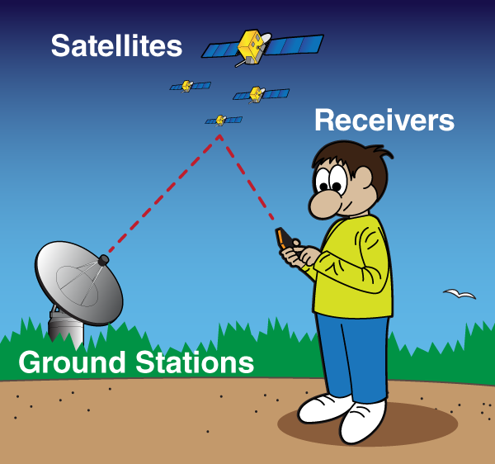
The Global Positioning System (GPS) is made up of satellites, ground stations, and receivers.
GPS is a system. It’s made up of three parts: satellites, ground stations, and receivers.

The ground stations use radar to make sure they are actually where we think they are.
A receiver, like you might find in your phone or in your car, is constantly listening for a signal from these satellites. The receiver figures out how far away they are from some of them.
Once the receiver calculates its distance from four or more satellites, it knows exactly where you are.

The Global Positioning System (GPS) is a network of about 30 satellites orbiting the Earth at an altitude of 20,000 km. The system was originally developed by the US government for military navigation but now anyone with a GPS device, be it a SatNav, mobile phone or handheld GPS unit, can receive the radio signals that the satellites broadcast.

Wherever you are on the planet, at least four GPS satellites are ‘visible’ at any time. Each one transmits information about its position and the current time at regular intervals. These signals, travelling at the speed of light, are intercepted by your GPS receiver, which calculates how far away each satellite is based on how long it took for the messages to arrive.

Once it has information on how far away at least three satellites are, your GPS receiver can pinpoint your location using a process called trilateration.

Trilateration
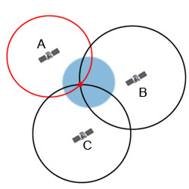
Imagine you are standing somewhere on Earth with three satellites in the sky above you. If you know how far away you are from satellite A, then you know you must be located somewhere on the red circle. If you do the same for satellites B and C, you can work out your location by seeing where the three circles intersect. This is just what your GPS receiver does, although it uses overlapping spheres rather than circles.

The more satellites there are above the horizon the more accurately your GPS unit can determine where you are.

GPS and Relativity

GPS satellites have atomic clocks on board to keep accurate time. General and Special Relativity however predict that differences will appear between these clocks and an identical clock on Earth.
Cloud Computing
Cloud computing is the on-demand delivery of compute power, database, storage, applications, and other IT resources via the internet with pay-as-you-go pricing.
Cloud computing is the the use of various services, such as software development platforms, servers, storage and software, over the internet, often referred to as the "cloud."
In general, there are three cloud computing characteristics that are common among all cloud-computing vendors:
- The back-end of the application (especially hardware) is completely managed by a cloud vendor.
- A user only pays for services used (memory, processing time and bandwidth, etc.).
- Services are scalable
Many cloud computing advancements are closely related to virtualization. The ability to pay on demand and scale quickly is largely a result of cloud computing vendors being able to pool resources that may be divided among multiple clients.
It is common to categorize cloud computing services as infrastructure as a service (IaaS), platform as a service (PaaS) or software as a service (SaaS).

Firmware refers to the software which is built on the Hardware to make the running perfect like the system BIOS etc.
HARDWARE is the physical stuff in your computer (CPU, GPU, ram etc.).
SOFTWARE is the programs on it, such as Microsoft Windows, Google chrome etc.

Use of E governance and various public domains and services
The “e” in e-government stands for electronic and is an old term that basically means digital.
So e-government refers to any electronic/digital media you would use to interact with your government, it could be submitting your tax returns online, emailing queries to a relevant government department, interacting with a government website, social media(Twitter) etc.
E-governance can be defined as the use of information & communication by government to enhance the range, quality of information & services provided to the citizen in an cost effective manner. Thus, e-Governance is basically associated with carrying out the functions and achieving the results of governance through the utilization of ICT (Information and Communications Technology).
E-Government refers to the
- Use of information technologies
- That have the ability to transform relations with citizens, businesses, and other arms of government .
- These technologies can serve better delivery of government services to citizens
E Government short for electronic government, also known as e gov, digital government, online government or transformational government. It is creating a comfortable, transparent and cheap interaction between government and citizens. As the era of Digital Economy evolves, the concept of good Governance assumes a greater significance. Thus, e-governance will result in improved transparency, speedy information dissemination, higher administrative efficiency and improved public services in sectors including transportation, education, power, health, water, security and the state administration and municipal services.
Advantages of E-Government
- Reducing Costs
- Promoting Economic development
- Improving Public Administration
- Facilitating an e-Society
- Enhancing Transparency and Accountability

